**Finding the sweet spot in camera trapping: a global synthesis and meta-analysis of net abundance and richness detection rates as an index of sampling effort.**

Nargol Ghazian*1 and Christopher J. Lortie1

1Department of Biology, York University, 4700 Keele St, Toronto, ON M3J 1P3, Canada

*Corresponding Author: Department of Biology, York University, 4700 Keele St, Toronto, ON, M3J 1P3, Canada. Email: [nargolg1@my.yorku.ca](mailto:nargolg1@my.yorku.ca)

**Abstract**

1. Camera traps have become one of the most common tools in wildlife biology documenting and measuring animal activity patterns and behaviour. Captures can be used to estimate population parameters such as presence/absence, relative abundance, habituate suitability, and resident species richness of specific populations.
2. A total of 292 full-text articles were returned from the Web of Science using the search terms Camera* Trap* and Richness* or Diversity*, and Rarefaction* Curve*. Full-text reviews of each for sampling effort in total number of days and total number of cameras returned 149 studies that reported animal abundance and species richness captured using this tool. We used an effect size measure for both net abundance and net richness detection rates to examine the relative performance of camera traps in different ecosystems.
3. The mean positive effect of increasing the number of cameras on net abundance detection rates was positive particularly in grasslands and mixed ecosystems. The mean net richness detection rate of the animal communities in most ecosystems also increased with relatively more cameras I think this might need a bit more nuanced - sounds really really obvious - so state weighted by days or mention whether linear etc… However, increasing the duration of trapping (number of days) within a specific region did not consistently increase abundance nor richness in any ecosystem?. This final result is super…
4. make a specific recommendation - researchers using camera traps should consider deploying more cameras for relatively shorter numbers of days to most accurately estimate animal species abundance and richness. (Only vertebrates here? If so just state once in abstract somewhere??

**Keywords**

Abundance, camera traps, diversity, meta-analysis, meta-regression, population estimates, richness, sampling effort.

**Introduction**

Monitoring and measuring the number of animals and diversity of animal communities in terrestrial ecosystems comprises an important set of methods in ecology and evolution. Camera traps are frequently a primary tool to survey wildlife and their interactions with the surrounding environment. These survey devices normally record animal presence via a triggered passive, infrared motion sensor (Rowcliffe et al. 2011). They are one of the most popular survey tools in current wildlife research particularly in the domain of terrestrial vertebrate biology (Meek et al. 2014). Cameras can record activity patterns and be used to infer occupancy, abundance, and species diversity (O’Connell, Nichols, and Karanth 2011; Kelly 2008). Camera traps have been also used in studies to examine behaviour (Rowcliffe et al. 2014), habitat use (Rovero et al. 2014), detection of rare species in a community (Thomas et al. 2020), estimation of population size and species richness (Whytock et al. 2021), population ecology measures (citation), and occupation of human-built structures (O’Connell, Nichols, and Karanth 2011). Thus, camera trap data can be used to quantify many ecological parameters and help advance theories such as niche partitioning, habitat use, as well as various behavioural models (Smith et al. 2020; Frey et al. 2017). Camera traps are also a fundamental biodiversity monitoring tool in critical ecosystems such as the Serengeti (Swanson et al. 2015) and the Amazon basin? (Trolle 2003). Anthropogenic changes are impacting species re-distribution and range shifts (Franklin 2010) and we need to be able to measure biodiversity for mobile species in different ways. Camera traps provide a relatively easy method that enables us to do this and gather big data (Norouzzadeh et al. 2018; Carl et al. 2020). These data can then be used to evaluate the efficacy of survey designs (Kays et al. 2020) to support management and conservation.

Various aspects can influence the number of species detected by camera traps as well as the trapping rate (ratio of photographs to camera trapping duration) (Rovero and Marshall 2009). The camera model, placement and orientation, temperature differentials, and species behavioural responses are some of the factors that impact the collected data (Meek, Ballard, and Fleming 2015). Thus, experimental decisions and methods include camera model, number of cameras, duration, and placement within a system. The factors above can be summarized as trapping effort and design and influence abundance and diversity estimates (Yasuda 2004; Wegge, Pokheral, and Jnawali 2004). Trapping rate is a useful index for abundance and diversity estimates (Rovero and Marshall 2009; Rowcliffe et al. 2008; Silveira, Jácomo, and Diniz-Filho 2003). Minimum trapping effort (MTE) is another important factor for population estimates (Si, Kays, and Ding 2014). MTE refers to the number of camera trap days required to record species of interest in an area and varies extensively across studies (Si, Kays, and Ding 2014). The number of camera traps used in a study is directly related to both trapping design and effort because a small number of cameras can result in low detection probabilities and affect the strength of population estimates (Foster and Harmsen 2012). The interplay amongst these elements provides us with an excellent opportunity to explore the relationship between trapping duration, number of cameras, and richness and abundance estimates across the literature, globally.

To evaluate the relative importance of sampling effort design decisions, we examine total number of camera and total numbers in a meta-analysis. We develop net abundance detection rate and net richness detection rate using effect size measures of incidence rates used in other field (citations). The global peer-reviewed literature was thus used to test the hypothesis that sampling effort positively but non-linearly influences the net animal abundance and richness detection rates at a site/region sampled. The importance of these critical design decision was also assessed for different ecosystems. Given that camera traps are increasingly used in ecology and evolution (Tabak et al. 2019), our study provides an insight into the ‘sweet spot’ for potentially optimal sampling. The capacity for this method to provide meaningful and sufficient animal data will better inform conservation and management practices and fundamental theory.

**Methods**

***Literature review***

We conducted a systematic review using the terms Camera Trap* and Richness*, or Diversity*, and Rarefaction* Curve* in ISI Web of Science (WoS) (Web of Science, 2021) as one search. This search was done in July 2021. Additionally, we conducted supplemental searches in book chapters and Google Scholar to validate the publication coverage of WoS. This process resulted in a total of 557 publications once duplicates were removed spanning the years 2001-2021. A PRISMA diagram illustrates the exclusion and review process (2009) (Supplementary material, Figure A). We used best practices to ensure that workflow and synthesis were reproducible and transparent (Bayliss and Beyer 2015). We screened the abstracts and excluded papers based on relevance, whether they were a review, opinion, or idea paper, focused on aquatic ecosystems, were not written in English (or English text version was unavailable), were qualitative, did not examine vertebrate species, and if they focused on one species or a group of animals (such as wild cats) and ignored other observed animals. A total of 292 full-text articles were further reviewed for a measure of richness or diversity, the number of captures and/or duration of camera trapping (i.e. days). Data were extracted from article text or table. Variables such as the location of study, number of cameras, sites, and ecosystem were also recorded.

***Meta-Analyses***

All meta-statistical analyses were performed in R version 4.1.0 (R Development Core Team 2021) using the package *metafor* version 3.0-2 (Viechtbauer 2010). Effect sizes were calculated using the number of species and the number of animals (captures) using the escalc function for incidence rates. Number of species or captures were independent event count variables??, and used as incidence rates r (PT Higgins, Li, and Deeks 2021). The incidence rates calculate the effect size measure by … number of animals or number of species against the total number of cameras and the total number of study days. Random-effects models (*rma)* were used to analyze estimated values and standard error for the number of animals/number of cameras/number of days and number of species/number of cameras/number of days using the method = "ML", test = “knha" with ecosystem serving as moderator. Hartung and Knapp (knha) is a test statistic based on the estimation function for the variance of the treatment overall effect estimator and keeps the prescribed significance level much better compared to other tests used in random-effect models (Hartung and Knapp 2001). Maximum likelihood (ML) refers to a method of estimation so that given the particular model the likelihood of producing that similar to ones that were actually observed are maximized. Weighted regression models were applied to analyze estimated values for the number of animals per number of cameras and the number of species per number of cameras over the total number of days. The method and test remained the same as above. Heterogeneity in all models was examined to ensure that variance was not unduly inflated from grouping similar measures into the random-effect models (Langan et al. 2019). Heterogeneity was tested by examining Cochran’s Q statistic (Bowden et al. 2011). Publication bias was tested using Egger’s regression test (Egger et al. 1997). SNAP.. SOO CLEAR.

Define mixed ecosystems above somewhere..

**Results**

A total of 149 articles were included in the meta-analysis comprising Y sites and Z total number of species. The supporting R scripts are published on Zenodo (Ghazian and Lortie, 2021), and data are published on KNB (Ghazian and Lortie 2021). The most common ecosystems for the studies were deciduous (25 studies) and tropical (38 studies). Observed vertebrates were small and large mammals, birds, and reptiles. Net abundance detection rate estimates resulted in an asymmetric funnel plot suggesting systematic differences between the studies (appendix to show funnel), and there was significant heterogeneity between the groups (Q = 4263163912.70 - this number seems way off - can you check math or redo, p<0.0001). Ecosystem was a significant moderator in the model for abundance? Or for richness rates? (F = 4.8830, p = 0.0003, *df* = 6). Net abundance detection rates were only significantly positive in grassland and mixed systems (Figure 1 and Table 1) - revise Abstract then - you say particularly. But it was only these two… A similar random-effect model for the net richness detection rate also showed significant heterogeneity between groups (Q = 1381336897.42 same.., p<0.0001). Ecosystem as a moderator was also significant (F = 14.79, p<0.0001, *df* = 6), and the net richness detection estimates were significantly positive in all ecosystems (Figure 1, Table 1), except in desert and coniferous forest. Regression analysis for abundance per camera regressed against the total number of days resulted in significant heterogeneity between groups (Figure 2, Q = 172482.25, p<0.0001, R2 = 0.00%). The same analysis for richness per cameras (Figure 2) also showed significantly positive heterogeneity (Q = 151603.35, p<0.0001, R2 = 0.73%). There was no effect of the duration of the study (i.e. n days) on abundance nor richness per camera deployed (stats).

**Results could use one more edit - go for it. Just make is super clear..**

**Discussion**

The importance of effective wildlife detection and estimating biodiversity is fundamental to community assembly of resident fauna and ultimately the management, conservation, and restoration of most ecosystems globally. The hypothesis that increasing sampling effort was supported in most ecosystems for number of cameras but not number of days. Deploying more camera traps, but not necessarily for more days, is likely the most effective ecological tool to estimate the relative abundance and local species richness for a variety of vertebrate species at least in grasslands and mixed ecosystems. Ecosystem was relevant and some systems clearly require additional study or different experimental design considerations to promote more effective and positive effect size measures for abundance and richness. Better implications.. — this evidence suggests that… at the minimum?? One should balance number of cameras versus number of days for some ecosystems and frame?? Quantitative expectations based on the returns published in similar studies or summarized in this synthesis.

Camera traps worked? effectively to estimate population parameters in virtually all ecosystems worldwide. Here, we did not only examine the relative importance of days but also the net abundance detection rate and net richness detection rate. Examining both these indices, we found evidence that richness and abundance was influenced by the number of cameras deployed at a site or region. The primary finding of this synthesis is that success in detecting species in a given system was highly dependent on the number of cameras. This is aligned with the findings of Ferreras et al. (2017) in a meta? Or was it a review? that similarly suggested that it is more efficient to deploy more camera traps for a shorter duration rather than to deploy fewer camera traps for a longer period. Efficient or effective? I think both of these ideas cool - did they say efficient? There is an expansion in the number of sites that camera traps are being used and most literature acknowledges the fact that one cannot discuss the notion of the number of cameras without talking about how far apart cameras were placed and how extensively the site was studied revise… If one chooses to increase sampling effort through more cameras, they need to consider a systematic trap placement design or a design suited to the habitat if the primary goal of the survey is richness estimation (O’Brien 2008) revise… To limit the chance of missing species, camera traps should not be too close together and maximize the total area covered (O’Connell, Nichols, and Karanth 2011) revise .MAKE ALL this more clear - set up - Number of cams important however there are least 3 other design decisions associated with camera deployment in addition to effect —- is placement? Habitat heterogeneity et… Sampling effort is a critical design topic in all of ecology and evolution and particularly in field studies. In this study, we found that increasing the number of trapping days past what? point did not increase the capacity of cameras to detect more animals neither in abundance nor diversity be more specific. This is directly related to Minimum Trapping Effort (MTE) (Si, Kays, and Ding 2014) because…it is the number of camera trap days required to record species of interest in an area record? Even once?. The interrelatedness of camera trap placement and the number of cameras is not an idea that we explored *per se*, though is integral in maximizing the potential of camera traps for wildlife monitoring. Understanding how many cameras are needed for how long, and how far apart they need to be placed relative to the particular ecosystem of study will ensure more precise wildlife and biodiversity monitoring of any given region. Needs work still for direct and clear language. Super ideas just tidy up.

It was striking that although grasslands and mixed ecosystems were not the most frequently Monitored? system of study and that increasing the number of cameras significantly increased the net abundance detection rate in these two systems. Arid and semi-arid systems are globally threatened with increased rates of anthropogenic changes, such as climate and land-use changes (Mahmoud and Gan 2018), and species in these regions face extensive ecological shifts (Barrows 2011; Bachelet et al. 2016). SO PROPOSE WHY now… easy to spot animals? One reason that animal abundance was higher in grasslands as opposed to other arid land may be due to the abundance of food, which conversely attracts prey (McDonald et al. 2015) revise … This in turn attracts more mid-size or larger mammals that feed on mice or birds alongside the natural grass (Silveira, Jácomo, and Malzoni Furtado 2005), overall increasing the total observed animal abundance in the area confusion here sorry you need to much more direct and clear. Similarly, mixed systems support relatively higher habitat diversity (Felton et al. 2010) because they are comprised of??? Many different types of plant species?? ; thus, naturally attracting a greater number of animals, potentially from a more diverse guild. Understanding how landscape-level differences influence animal assemblage in different ecosystems offers us valuable insight into the utility of camera traps in different regions. Still needs work.

OK so Discussion needs one more hard and super clear edit by you :) then we are done!!

**Implications**

Anthropogenic changes influence species distribution in ways revise that intensive monitoring of local species in different regions will be critical for the maintenance of biodiversity and the implementation of management practices revise - weak. This synthesis provides both a critical insight into experimental design considerations associated with sampling effort and of the relative efficacy of camera traps as a tool in monitoring changes in wildlife populations in different ecosystems. Camera traps are a powerful instrument whose popularity in wildlife research has increased tremendously (Forrester et al. 2016)??/ so??. revise… we will also see a rise in their cross implementation in AI and machine-learning environmental monitoring studies (Tabak et al. 2019; Willi et al. 2019). revise.. KEEP on target with what this study did… lol Experimental designs need to consider the physical size of species, the ecosystem of study, landscape features, the benefits and disadvantages of using bait, and the size and range of populations. Obvious next steps to our study would be to test range and placement relative to the ecosystem of study. Needs more punch.

**Acknowledgments**

This research was made possible through a Natural Sciences and Engineering Research Council of Canada (NSERC) grant awarded to CJL. NG and CJL declare no conflict of interest.

**Author**’**s contributions**

NG and CJL designed the study and methodologies; NG wrote the manuscript; NG and CJL analyzed the data; CJL thoroughly edited the manuscript and contributed critically.

Notes on font changes…

**Work Cited**

Bachelet, D., K. Ferschweiler, T. Sheehan, and J. Strittholt. 2016. “Climate Change Effects on Southern California Deserts.” *Journal of Arid Environments* 127 (April): 17–29. https://doi.org/10.1016/j.jaridenv.2015.10.003.

Barrows, C.W. 2011. “Sensitivity to Climate Change for Two Reptiles at the Mojave–Sonoran Desert Interface.” *Journal of Arid Environments* 75 (7): 629–35. https://doi.org/10.1016/j.jaridenv.2011.01.018.

Bayliss, Helen R., and Fiona R. Beyer. 2015. “Information Retrieval for Ecological Syntheses: Information Retrieval for Ecological Syntheses.” *Research Synthesis Methods* 6 (2): 136–48. https://doi.org/10.1002/jrsm.1120.

Bowden, Jack, Jayne F Tierney, Andrew J Copas, and Sarah Burdett. 2011. “Quantifying, Displaying and Accounting for Heterogeneity in the Meta-Analysis of RCTs Using Standard and Generalised Qstatistics.” *BMC Medical Research Methodology* 11 (1): 41. https://doi.org/10.1186/1471-2288-11-41.

Carl, Christin, Fiona Schönfeld, Ingolf Profft, Alisa Klamm, and Dirk Landgraf. 2020. “Automated Detection of European Wild Mammal Species in Camera Trap Images with an Existing and Pre-Trained Computer Vision Model.” *European Journal of Wildlife Research* 66 (4): 62. https://doi.org/10.1007/s10344-020-01404-y.

Egger, M., G. D. Smith, M. Schneider, and C. Minder. 1997. “Bias in Meta-Analysis Detected by a Simple, Graphical Test.” *BMJ* 315 (7109): 629–34. https://doi.org/10.1136/bmj.315.7109.629.

Felton, Adam, Matts Lindbladh, Jörg Brunet, and Örjan Fritz. 2010. “Replacing Coniferous Monocultures with Mixed-Species Production Stands: An Assessment of the Potential Benefits for Forest Biodiversity in Northern Europe.” *Forest Ecology and Management* 260 (6): 939–47. https://doi.org/10.1016/j.foreco.2010.06.011.

Ferreras, P., F. Díaz-Ruiz, P. C. Alves, and P. Monterroso. 2017. “Optimizing Camera-Trapping Protocols for Characterizing Mesocarnivore Communities in South-Western Europe.” *Journal of Zoology* 301 (1): 23–31. https://doi.org/10.1111/jzo.12386.

Forrester, Tavis, Tim O’Brien, Eric Fegraus, Patrick Jansen, Jonathan Palmer, Roland Kays, Jorge Ahumada, Beth Stern, and William McShea. 2016. “An Open Standard for Camera Trap Data.” *Biodiversity Data Journal* 4 (December): e10197. https://doi.org/10.3897/BDJ.4.e10197.

Foster, Rebecca J., and Bart J. Harmsen. 2012. “A Critique of Density Estimation from Camera-Trap Data: Density Estimation From Camera-Trap Data.” *The Journal of Wildlife Management* 76 (2): 224–36. https://doi.org/10.1002/jwmg.275.

Franklin, Janet. 2010. “Moving beyond Static Species Distribution Models in Support of Conservation Biogeography: Moving beyond Static Species Distribution Models.” *Diversity and Distributions* 16 (3): 321–30. https://doi.org/10.1111/j.1472-4642.2010.00641.x.

Frey, Sandra, Jason T. Fisher, A. Cole Burton, and John P. Volpe. 2017. “Investigating Animal Activity Patterns and Temporal Niche Partitioning Using Camera-Trap Data: Challenges and Opportunities.” Edited by Marcus Rowcliffe. *Remote Sensing in Ecology and Conservation* 3 (3): 123–32. https://doi.org/10.1002/rse2.60.

Ghazian, Nargol, and Christopher Lortie. 2021. “A Global Synthesis and Meta-Analysis of Net Capture Abundance and Richness Detection Rates as an Index of Sampling Effort, 2021.” Text/xml. KNB Data Repository. https://doi.org/10.5063/3J3BC3.

Hartung, Joachim, and Guido Knapp. 2001. “On Tests of the Overall Treatment Effect in Meta-Analysis with Normally Distributed Responses.” *Statistics in Medicine* 20 (12): 1771–82. https://doi.org/10.1002/sim.791.

Kays, Roland, Brian S. Arbogast, Megan Baker‐Whatton, Chris Beirne, Hailey M. Boone, Mark Bowler, Santiago F. Burneo, et al. 2020. “An Empirical Evaluation of Camera Trap Study Design: How Many, How Long and When?” Edited by Diana Fisher. *Methods in Ecology and Evolution* 11 (6): 700–713. https://doi.org/10.1111/2041-210X.13370.

Kelly, M. J. 2008. “Design, Evaluate, Refine: Camera Trap Studies for Elusive Species.” *Animal Conservation* 11 (3): 182–84. https://doi.org/10.1111/j.1469-1795.2008.00179.x.

Langan, Dean, Julian P.T. Higgins, Dan Jackson, Jack Bowden, Areti Angeliki Veroniki, Evangelos Kontopantelis, Wolfgang Viechtbauer, and Mark Simmonds. 2019. “A Comparison of Heterogeneity Variance Estimators in Simulated Random‐effects Meta‐analyses.” *Research Synthesis Methods* 10 (1): 83–98. https://doi.org/10.1002/jrsm.1316.

Mahmoud, Shereif H., and Thian Y. Gan. 2018. “Impact of Anthropogenic Climate Change and Human Activities on Environment and Ecosystem Services in Arid Regions.” *Science of The Total Environment* 633 (August): 1329–44. https://doi.org/10.1016/j.scitotenv.2018.03.290.

Marcus Rowcliffe, J., Chris Carbone, Patrick A. Jansen, Roland Kays, and Bart Kranstauber. 2011. “Quantifying the Sensitivity of Camera Traps: An Adapted Distance Sampling Approach: *Quantifying Camera Trap Sensitivity*.” *Methods in Ecology and Evolution* 2 (5): 464–76. https://doi.org/10.1111/j.2041-210X.2011.00094.x.

McDonald, Peter J., Anthony D. Griffiths, Catherine E.M. Nano, Chris R. Dickman, Simon J. Ward, and Gary W. Luck. 2015. “Landscape-Scale Factors Determine Occupancy of the Critically Endangered Central Rock-Rat in Arid Australia: The Utility of Camera Trapping.” *Biological Conservation* 191 (November): 93–100. https://doi.org/10.1016/j.biocon.2015.06.027.

Meek, Paul D., Guy-Anthony Ballard, and Peter J. S. Fleming. 2015. “The Pitfalls of Wildlife Camera Trapping as a Survey Tool in Australia.” *Australian Mammalogy* 37 (1): 13. https://doi.org/10.1071/AM14023.

Meek, Paul, Peter J. S Fleming, Guy Ballard, Peter Banks, Andrew W Claridge, James Sanderson, Don E Swann, Australasian Wildlife Management Society, and Royal Zoological Society of New South Wales, eds. 2014. *Camera Trapping: Wildlife Management and Research*.

Moher, David, Alessandro Liberati, Jennifer Tetzlaff, Douglas G. Altman, and The PRISMA Group. 2009. “Preferred Reporting Items for Systematic Reviews and Meta-Analyses: The PRISMA Statement.” *PLoS Medicine* 6 (7): e1000097. https://doi.org/10.1371/journal.pmed.1000097.

Norouzzadeh, Mohammad Sadegh, Anh Nguyen, Margaret Kosmala, Alexandra Swanson, Meredith S. Palmer, Craig Packer, and Jeff Clune. 2018. “Automatically Identifying, Counting, and Describing Wild Animals in Camera-Trap Images with Deep Learning.” *Proceedings of the National Academy of Sciences* 115 (25): E5716–25. https://doi.org/10.1073/pnas.1719367115.

O’Brien, T. G. 2008. “On the Use of Automated Cameras to Estimate Species Richness for Large- and Medium-Sized Rainforest Mammals.” *Animal Conservation* 11 (3): 179–81. https://doi.org/10.1111/j.1469-1795.2008.00178.x.

O’Connell, Allan F., James D. Nichols, and K. Ullas Karanth, eds. 2011. *Camera Traps in Animal Ecology: Methods and Analyses / Allan F. O’Connell, James D. Nichols, K. Ullas Karanth, Editors*. Tokyo ; New York: Springer.

PT Higgins, Julian, Tianjing Li, and Jonathan J. Deeks. 2021. “Choosing Effect Measures and Computing Estimates of Effect.” *Cochrane Training* (blog). 2021. https://training.cochrane.org/handbook/current/chapter-06#section-6-1.

R Development Core Team. 2021. *R* (version 4.0.4).

Rovero, Francesco, and Andrew R. Marshall. 2009. “Camera Trapping Photographic Rate as an Index of Density in Forest Ungulates.” *Journal of Applied Ecology* 46 (5): 1011–17. https://doi.org/10.1111/j.1365-2664.2009.01705.x.

Rovero, Francesco, Emanuel Martin, Melissa Rosa, Jorge A. Ahumada, and Daniel Spitale. 2014. “Estimating Species Richness and Modelling Habitat Preferences of Tropical Forest Mammals from Camera Trap Data.” Edited by Danilo Russo. *PLoS ONE* 9 (7): e103300. https://doi.org/10.1371/journal.pone.0103300.

Rowcliffe, J. Marcus, Juliet Field, Samuel T. Turvey, and Chris Carbone. 2008. “Estimating Animal Density Using Camera Traps without the Need for Individual Recognition.” *Journal of Applied Ecology* 45 (4): 1228–36. https://doi.org/10.1111/j.1365-2664.2008.01473.x.

Rowcliffe, J. Marcus, Roland Kays, Bart Kranstauber, Chris Carbone, and Patrick A. Jansen. 2014. “Quantifying Levels of Animal Activity Using Camera Trap Data.” Edited by Diana Fisher. *Methods in Ecology and Evolution* 5 (11): 1170–79. https://doi.org/10.1111/2041-210X.12278.

Si, Xingfeng, Roland Kays, and Ping Ding. 2014. “How Long Is Enough to Detect Terrestrial Animals? Estimating the Minimum Trapping Effort on Camera Traps.” *PeerJ* 2 (May): e374. https://doi.org/10.7717/peerj.374.

Silveira, Leandro, Anah T.A. Jácomo, and José Alexandre F. Diniz-Filho. 2003. “Camera Trap, Line Transect Census and Track Surveys: A Comparative Evaluation.” *Biological Conservation* 114 (3): 351–55. https://doi.org/10.1016/S0006-3207(03)00063-6.

Silveira, Leandro, Anah T.A. Jácomo, and Mariana Malzoni Furtado. 2005. “Pampas Cat Ecology and Conservation in the Brazilian Grasslands.”

Smith, Justine A., Justin P. Suraci, Jennifer S. Hunter, Kaitlyn M. Gaynor, Carson B. Keller, Meredith S. Palmer, Justine L. Atkins, et al. 2020. “Zooming in on Mechanistic Predator–Prey Ecology: Integrating Camera Traps with Experimental Methods to Reveal the Drivers of Ecological Interactions.” Edited by Ben Dantzer. *Journal of Animal Ecology* 89 (9): 1997–2012. https://doi.org/10.1111/1365-2656.13264.

Swanson, Alexandra, Margaret Kosmala, Chris Lintott, Robert Simpson, Arfon Smith, and Craig Packer. 2015. “Snapshot Serengeti, High-Frequency Annotated Camera Trap Images of 40 Mammalian Species in an African Savanna.” *Scientific Data* 2 (1): 150026. https://doi.org/10.1038/sdata.2015.26.

Tabak, Michael A., Mohammad S. Norouzzadeh, David W. Wolfson, Steven J. Sweeney, Kurt C. Vercauteren, Nathan P. Snow, Joseph M. Halseth, et al. 2019. “Machine Learning to Classify Animal Species in Camera Trap Images: Applications in Ecology.” Edited by Theoni Photopoulou. *Methods in Ecology and Evolution* 10 (4): 585–90. https://doi.org/10.1111/2041-210X.13120.

Thomas, Morgan L., Lynn Baker, James R. Beattie, and Andrew M. Baker. 2020. “Determining the Efficacy of Camera Traps, Live Capture Traps, and Detection Dogs for Locating Cryptic Small Mammal Species.” *Ecology and Evolution* 10 (2): 1054–68. https://doi.org/10.1002/ece3.5972.

Trolle, M. 2003. “Mammal Survey in the Rio Jauaperí Region, Rio Negro Basin, the Amazon, Brazil.” *Mammalia* 67 (1). https://doi.org/10.1515/mamm.2003.67.1.75.

Viechtbauer, Wolfgang. 2010. “Conducting Meta-Analyses in *R* with the **Metafor** Package.” *Journal of Statistical Software* 36 (3). https://doi.org/10.18637/jss.v036.i03.

“Web of Science.” 2021. https://www.webofknowledge.com.

Wegge, Per, Chiranjibi Pd. Pokheral, and Shant Raj Jnawali. 2004. “Effects of Trapping Effort and Trap Shyness on Estimates of Tiger Abundance from Camera Trap Studies.” *Animal Conservation* 7 (3): 251–56. https://doi.org/10.1017/S1367943004001441.

Whytock, Robin C., Jędrzej Świeżewski, Joeri A. Zwerts, Tadeusz Bara‐Słupski, Aurélie Flore Koumba Pambo, Marek Rogala, Laila Bahaa‐el‐din, et al. 2021. “Robust Ecological Analysis of Camera Trap Data Labelled by a Machine Learning Model.” Edited by Carlos Alberto Silva. *Methods in Ecology and Evolution*, March, 2041-210X.13576. https://doi.org/10.1111/2041-210X.13576.

Willi, Marco, Ross T. Pitman, Anabelle W. Cardoso, Christina Locke, Alexandra Swanson, Amy Boyer, Marten Veldthuis, and Lucy Fortson. 2019. “Identifying Animal Species in Camera Trap Images Using Deep Learning and Citizen Science.” Edited by Oscar Gaggiotti. *Methods in Ecology and Evolution* 10 (1): 80–91. https://doi.org/10.1111/2041-210X.13099.

Yasuda, Masatoshi. 2004. “Monitoring Diversity and Abundance of Mammals with Camera Traps: A Case Study on Mount Tsukuba, Central Japan.” *Mammal Study* 29 (1): 37–46. https://doi.org/10.3106/mammalstudy.29.37.

**Figures and Tables**

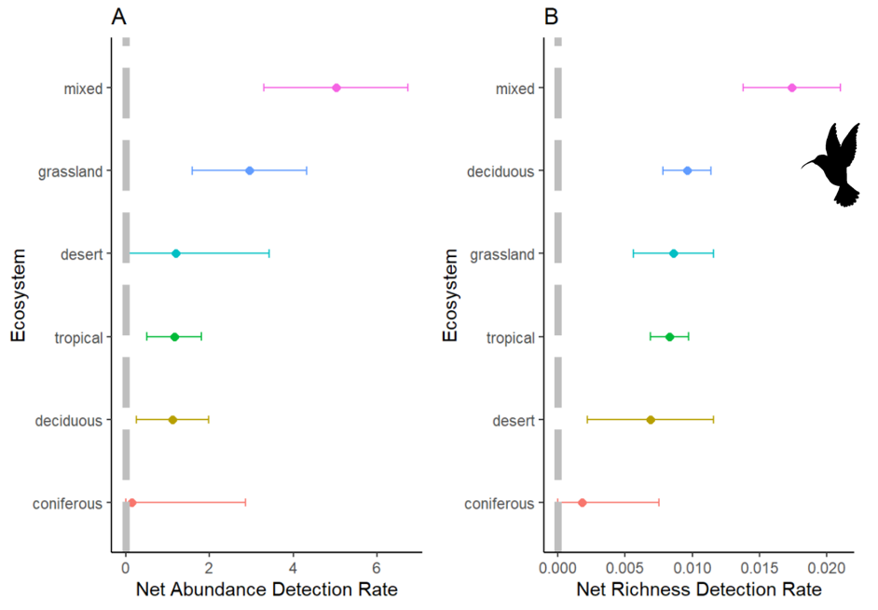

**Figure 1. Forest plots showing estimate effect sizes from random-mixed model output for net abundance detection rate (A, number of animals/number of cameras/number of days) and net richness detection rate (B, number of species/number of cameras/number of days) in 6 different ecosystems of study. Dots represent the meta-analytic mean and dashed lines represent the 95% confidence intervals.**

**Use icons to communicate idea**

**Square up boxes for each panel?**

**Maybe dots one size bigger too please?**

**Get rid of the end hatches on error bars**

**I think this code?**

geom_errorbar(aes(ymin=y_min_error, ymax=y_max_error),width=0,) + # y error bar

geom_errorbarh(aes(xmin=x_min_error, xmax=x_max_error),height=0) + # x error bar

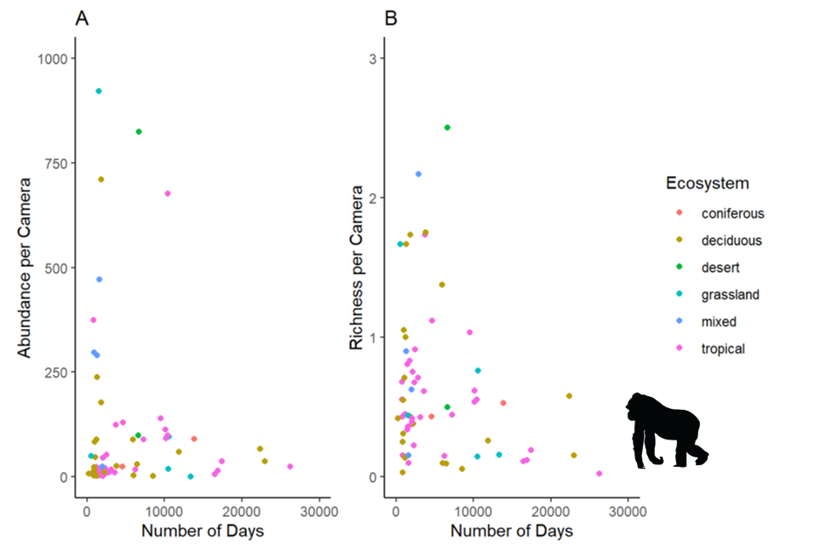

**Figure 2. Weighted regression plot showing the relationship between the number of animals per camera (A) and the number of species per camera (B) throughout the duration of the study (days), weighted by the variation in abundance or richness. Coloured dots represent the ecosystem of study.**

**Table 1. Mixed-effect model estimates and standard error (SE) for net abundance detection rate (number of animals/number of cameras/number of days) and net richness detection rate (number of species/number of cameras/number) are given for each ecosystem. Significant p-Values are bolded.**

|  |  |  |  |  |  |  |
| --- | --- | --- | --- | --- | --- | --- |
| ***Net Abundance Detection Rate*** | | | | | | |
| **Ecosystem** | ***Estimate*** | ***SE(±)*** | ***t-Value*** | ***95% CI.lb*** | ***95% CI.ub*** | ***p-Value*** |
| ***Coniferous*** | 0.1417 | 2.6849 | 0.0528 | -5.2057 | 5.4891 | 0.9580 |
| ***Deciduous*** | 1.0125 | 0.7594 | 1.3333 | -0.5000 | 2.5250 | 0.1864 |
| ***Desert*** | 1.1951 | 2.1922 | 0.5452 | -3.1710 | 5.5612 | 0.5872 |
| ***Grassland*** | 2.9580 | 1.3424 | 2.2035 | 0.2843 | 5.6317 | **0.0306** |
| ***Mixed*** | 6.8013 | 1.5501 | 4.3876 | 3.7139 | 9.8886 | **<0.0001** |
| ***Tropical*** | 1.0870 | 0.6160 | 1.7647 | -0.1398 | 2.3138 | 0.0816 |
| ***Net Richness Detection Rate*** | | | | | | |
| **Ecosystem** | ***Estimate*** | ***SE(±)*** | ***t-Value*** | ***95% CI.lb*** | ***95% CI.ub*** | ***p-Value*** |
| ***Coniferous*** | 0.0018 | 0.0063 | 0.2825 | -0.0108 | 0.0144 | 0.7784 |
| ***Deciduous*** | 0.0104 | 0.0018 | 5.8472 | 0.0069 | 0.0140 | **<0.0001** |
| ***Desert*** | 0.0069 | 0.0052 | 1.3454 | -0.0033 | 0.0172 | 0.1826 |
| ***Grassland*** | 0.0086 | 0.0034 | 2.5522 | 0.0019 | 0.0153 | **0.0127** |
| ***Mixed*** | 0.0153 | 0.0036 | 4.2010 | 0.0081 | 0.0226 | **<0.0001** |
| ***Tropical*** | 0.0077 | 0.0014 | 5.3384 | 0.0048 | 0.0106 | **<0.0001** |

**Supplementary Appendix**

Papers obtained through database searching (Web of Science) Keywords:

Camera* Trap* AND Richness*, Diversity*, and Rarefaction* Curve*

(n= 716)

(n = 1090)

## Identification

Papers obtained from other sources, such as book chapter bibliographies

(n= 0)

## Eligibility

Records after duplicates removed   
(n = 557)

Records excluded for: relevance, review, opinion or idea paper, focus on one species, qualitative, not English.

Records screened by abstract (n = 557)

## Screening

Full-text articles excluded:

Not reporting richness or diversity, number of records, and any measure of duration, aquatic studies.

Full-text articles assessed for eligibility (n = 292)

(n = )

Include in synthesis

(n = 149)

## Included

Extracted data:

Location (latitude, longitude), camera trap days, number of records, animal richness, common name, scientific name, year, number of cameras, presence of bait, number of cameras, number of sites, and ecosystem.

**A. PRISMA diagram used for camera trapping effort systematic review (Moher et al. 2009). Search was done with keywords: Camera* Trap* and Richness*, or Diversity*, and Rarefaction* Curve* in May of 2021.**